**Assignment Day 15 and 16**

**Question 1: Working with Lambda**

Step1: Create two s3 buckets with the name

ss: s3 console with two buckets

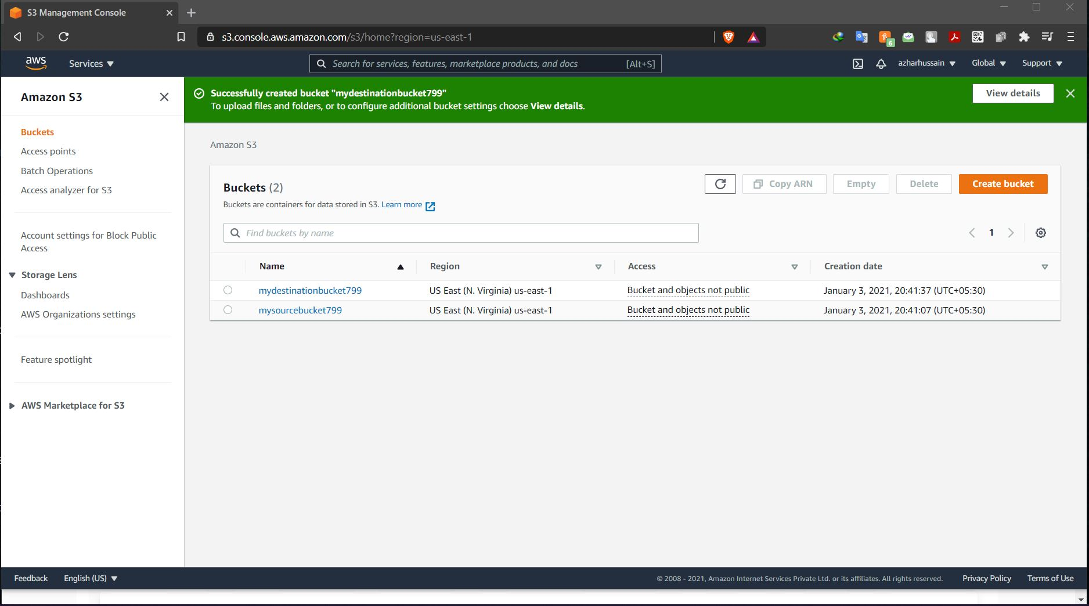

Step2: Create a policy with limited Read-write permissions using a JSON script

ss: json script in place

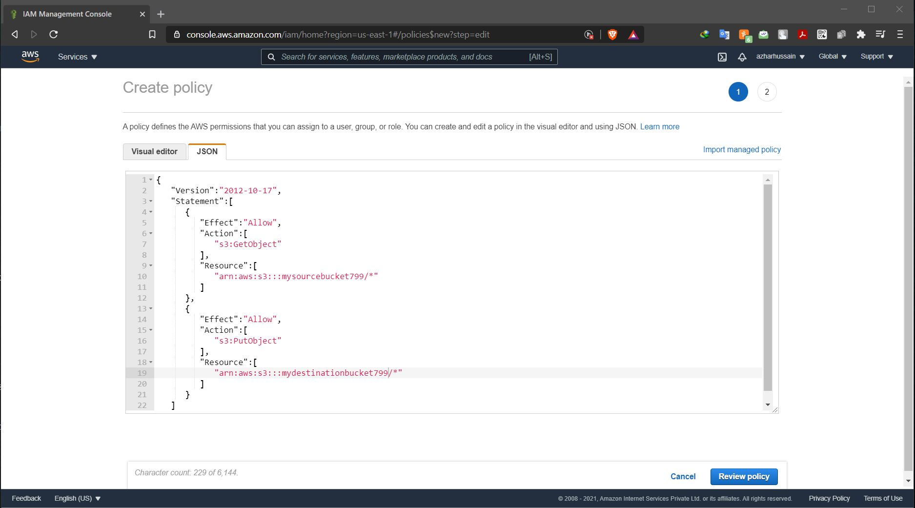

ss: policy console with your policy filtered

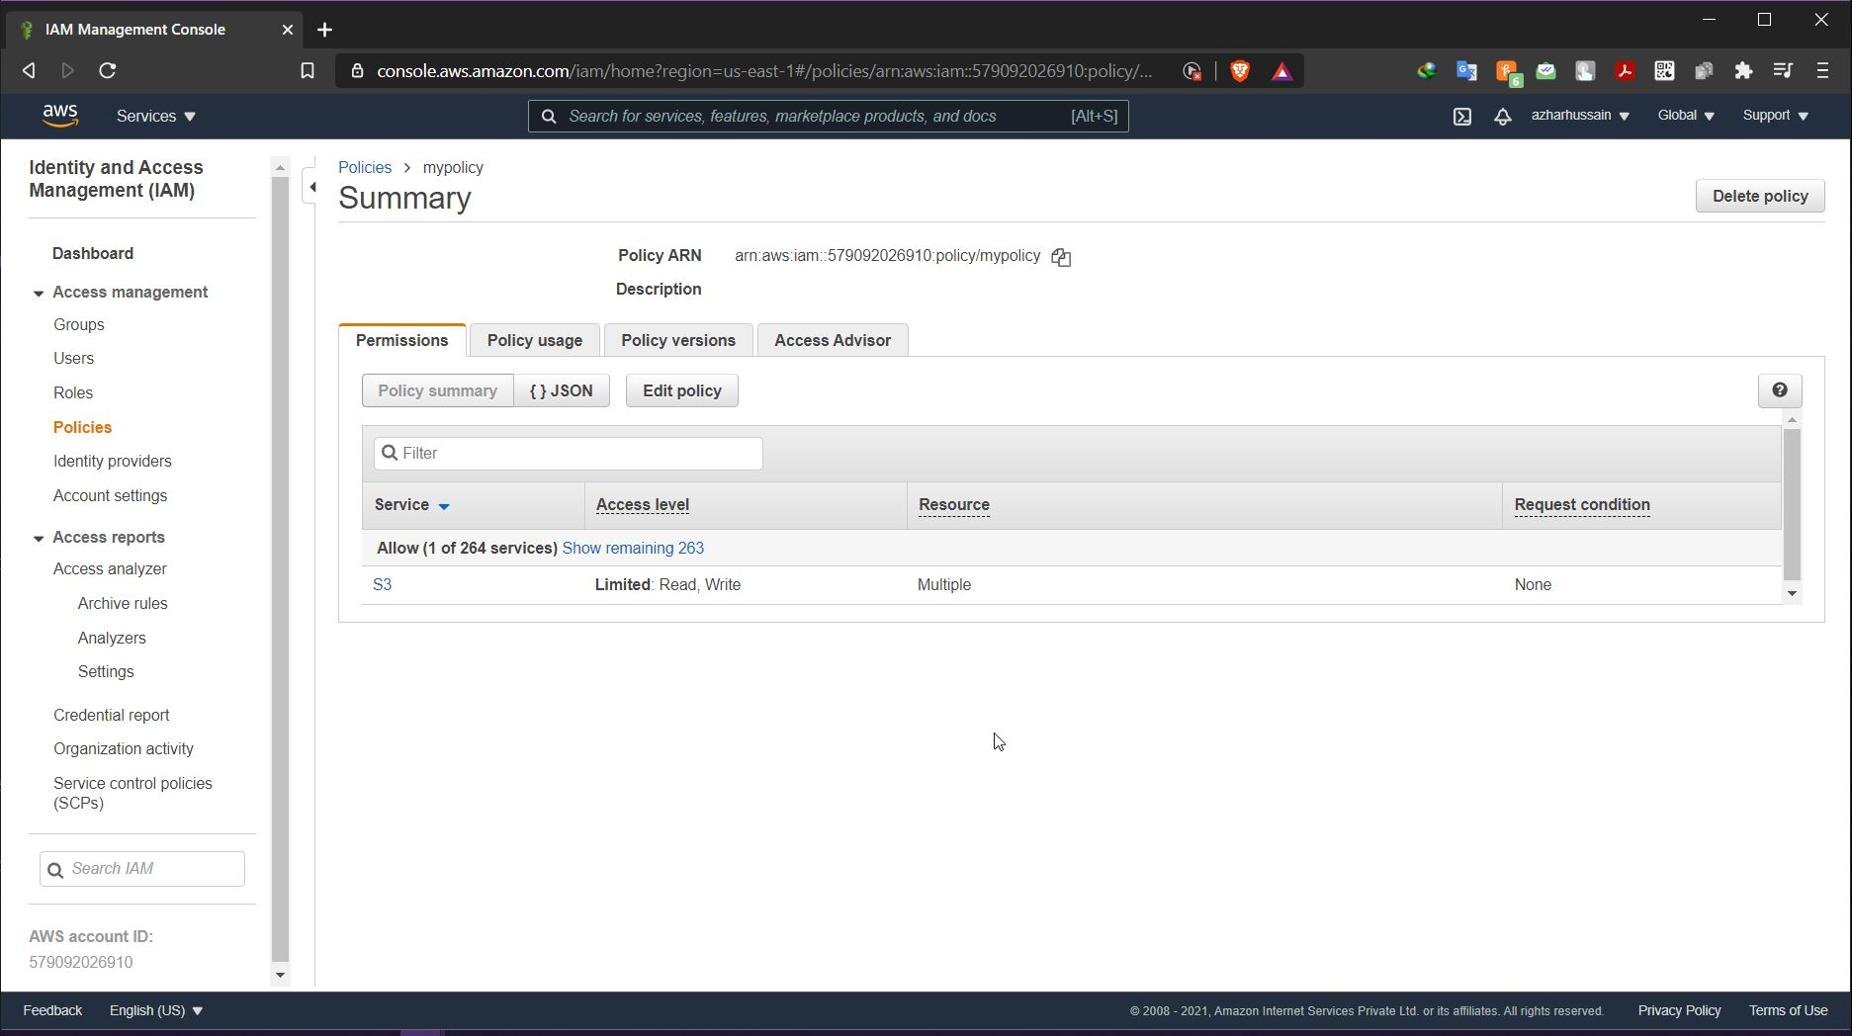

Step3: Create a role and attach the policy that was created in the previous step.

ss: Role console showing details of the role

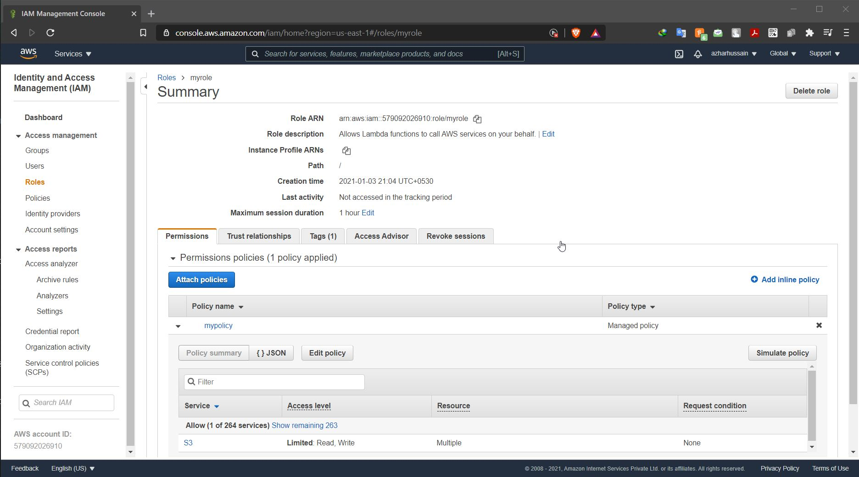

Step4: Create a Lambda function

ss: lambda functions dashboard

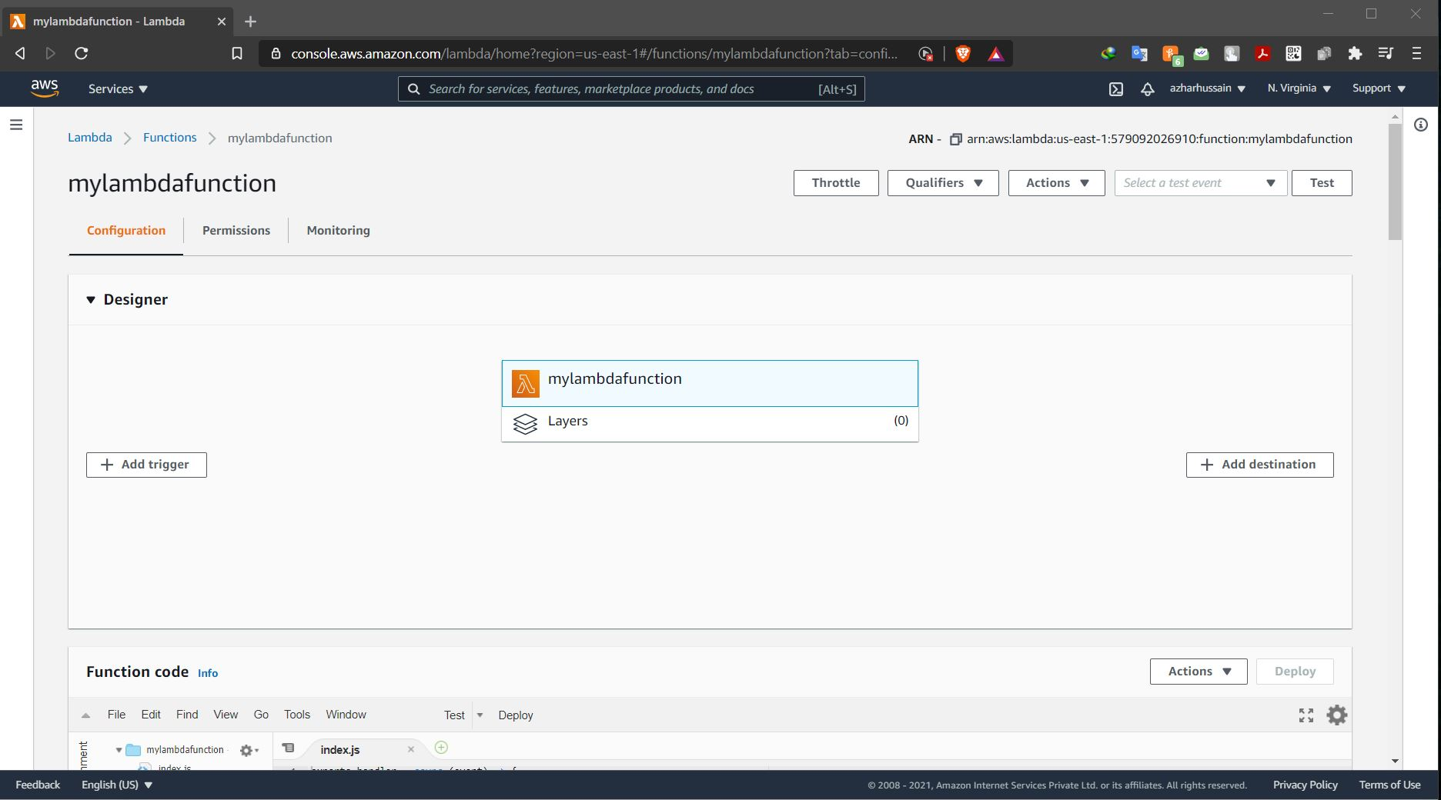

ss: js file edited

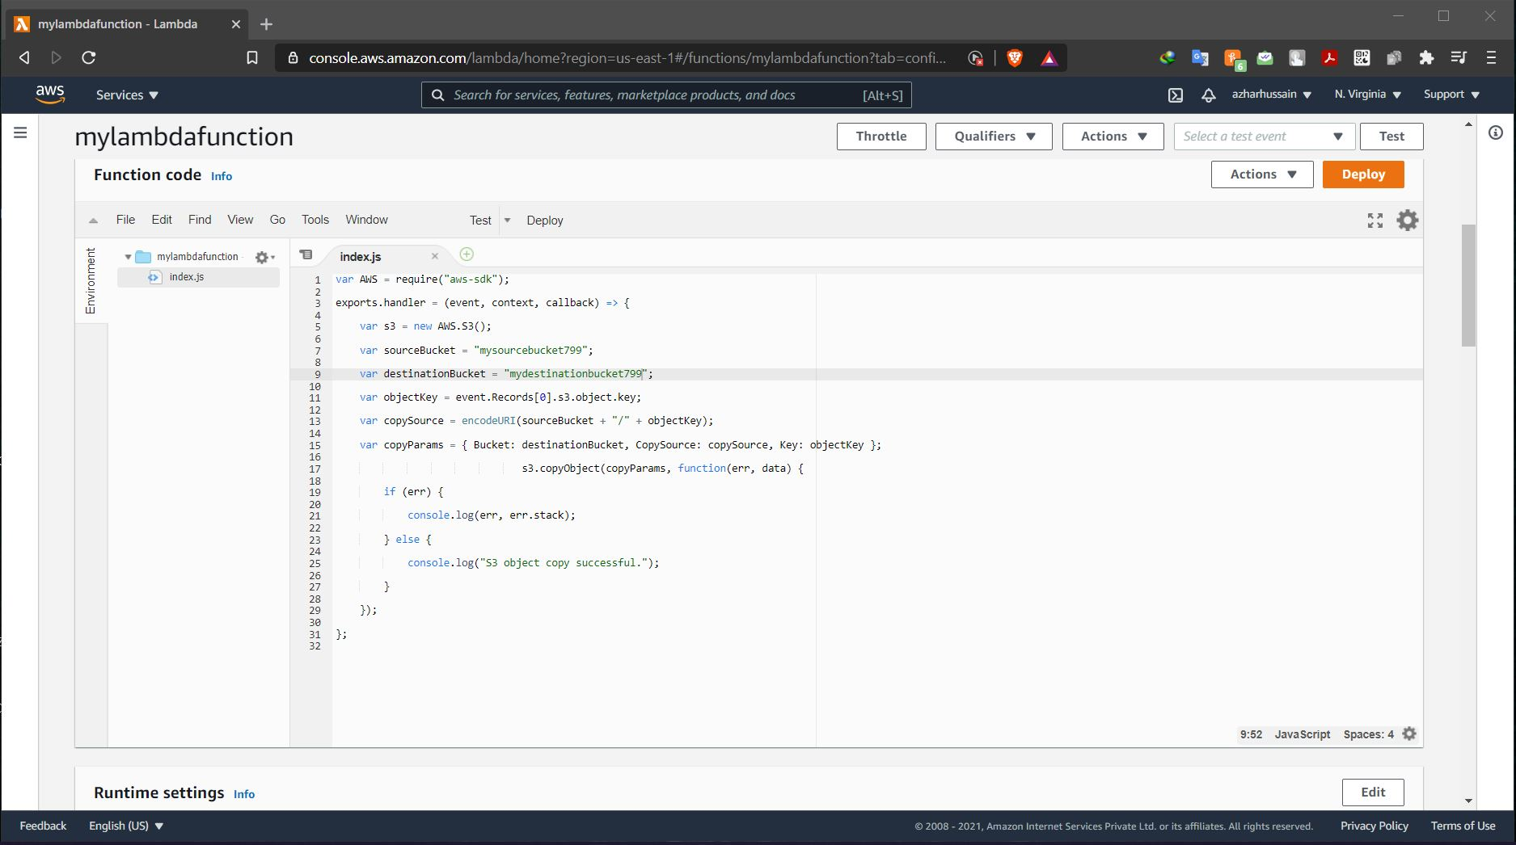

ss: adding trigger-s3, bucket name, confirmation for having separate buckets

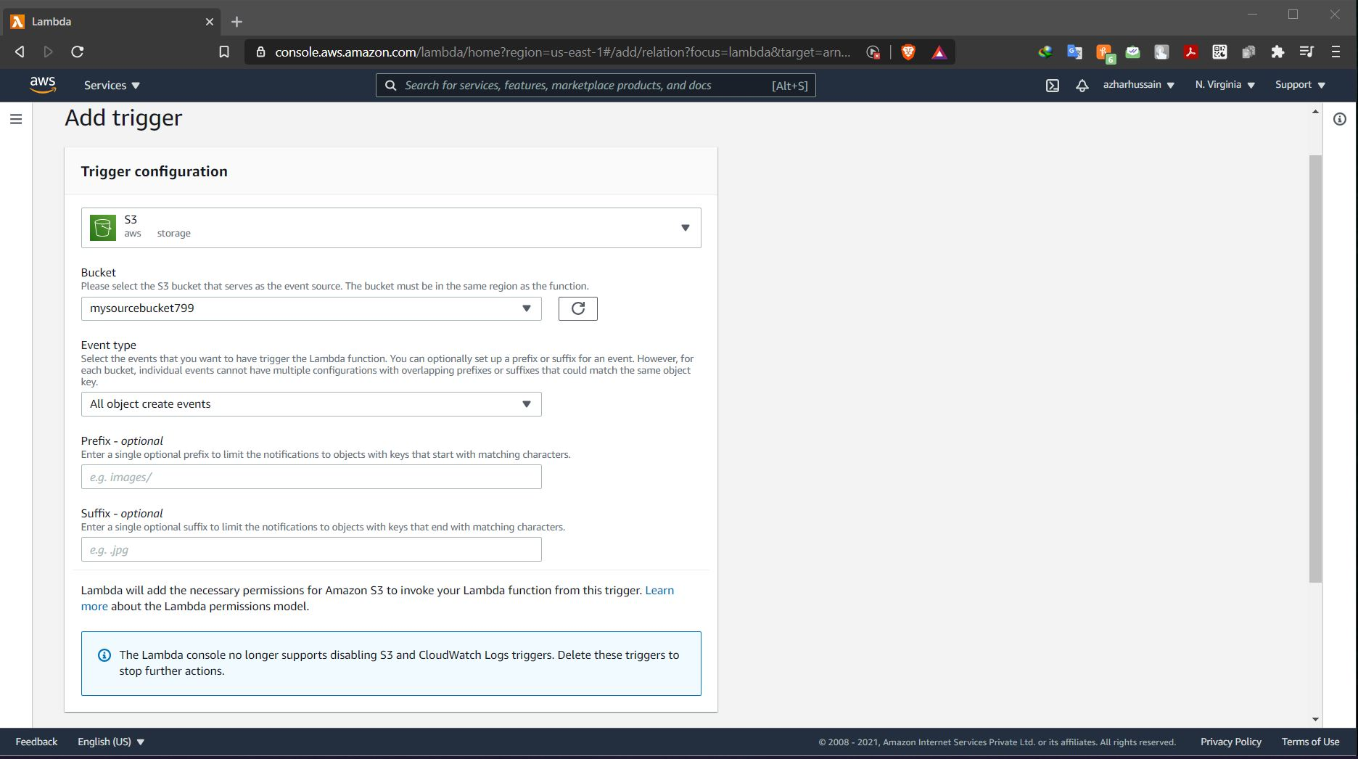

Step5: Adding triggers to the lambda function

ss: lambda configuration page with trigger added

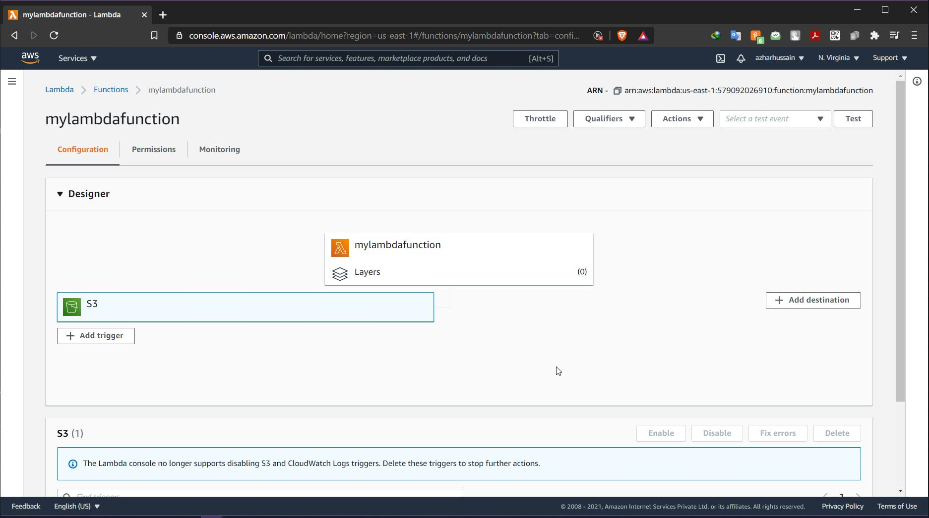

Step6: Test by uploading objects into the source bucket

ss: object uploaded in the source bucket

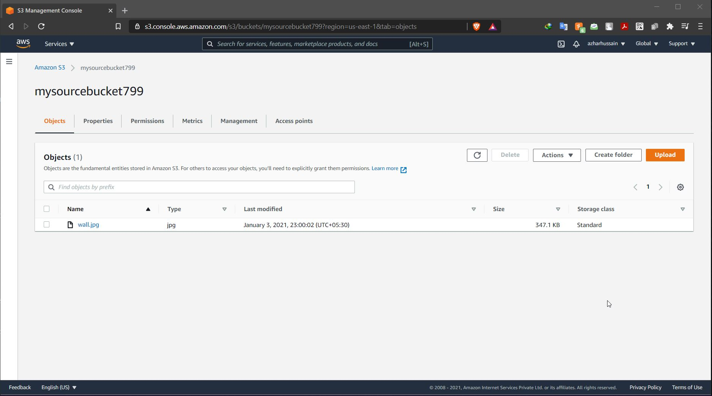

ss: object replicated in the destination bucket.

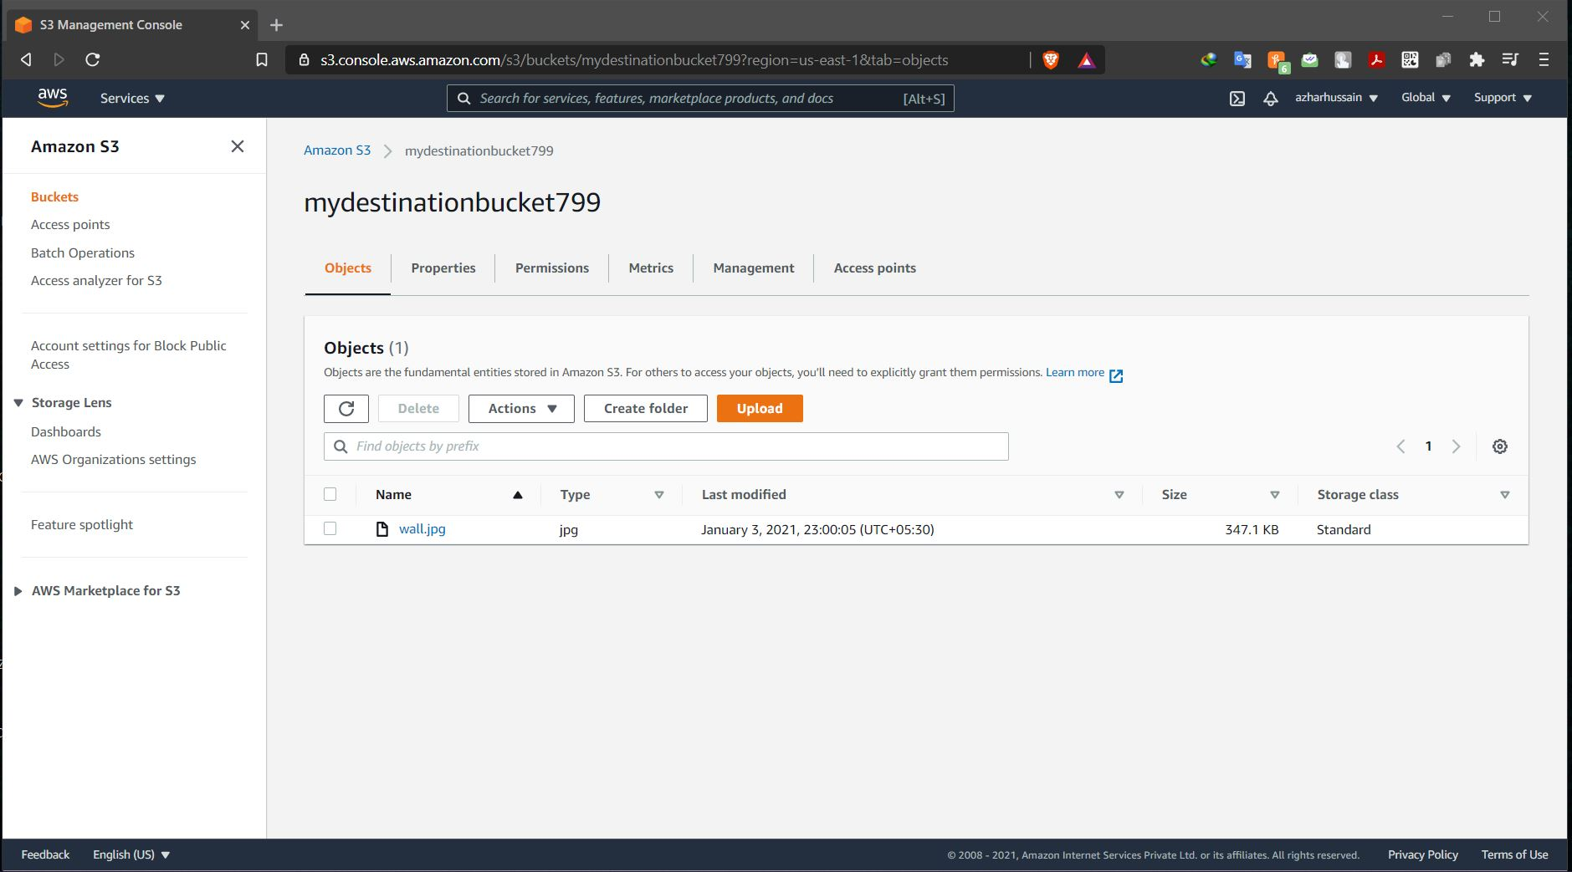

**Question 2: Working with Elastic container service using fargate**

Step1: Getting started with amazon ECS using fargate

ss: ECS console

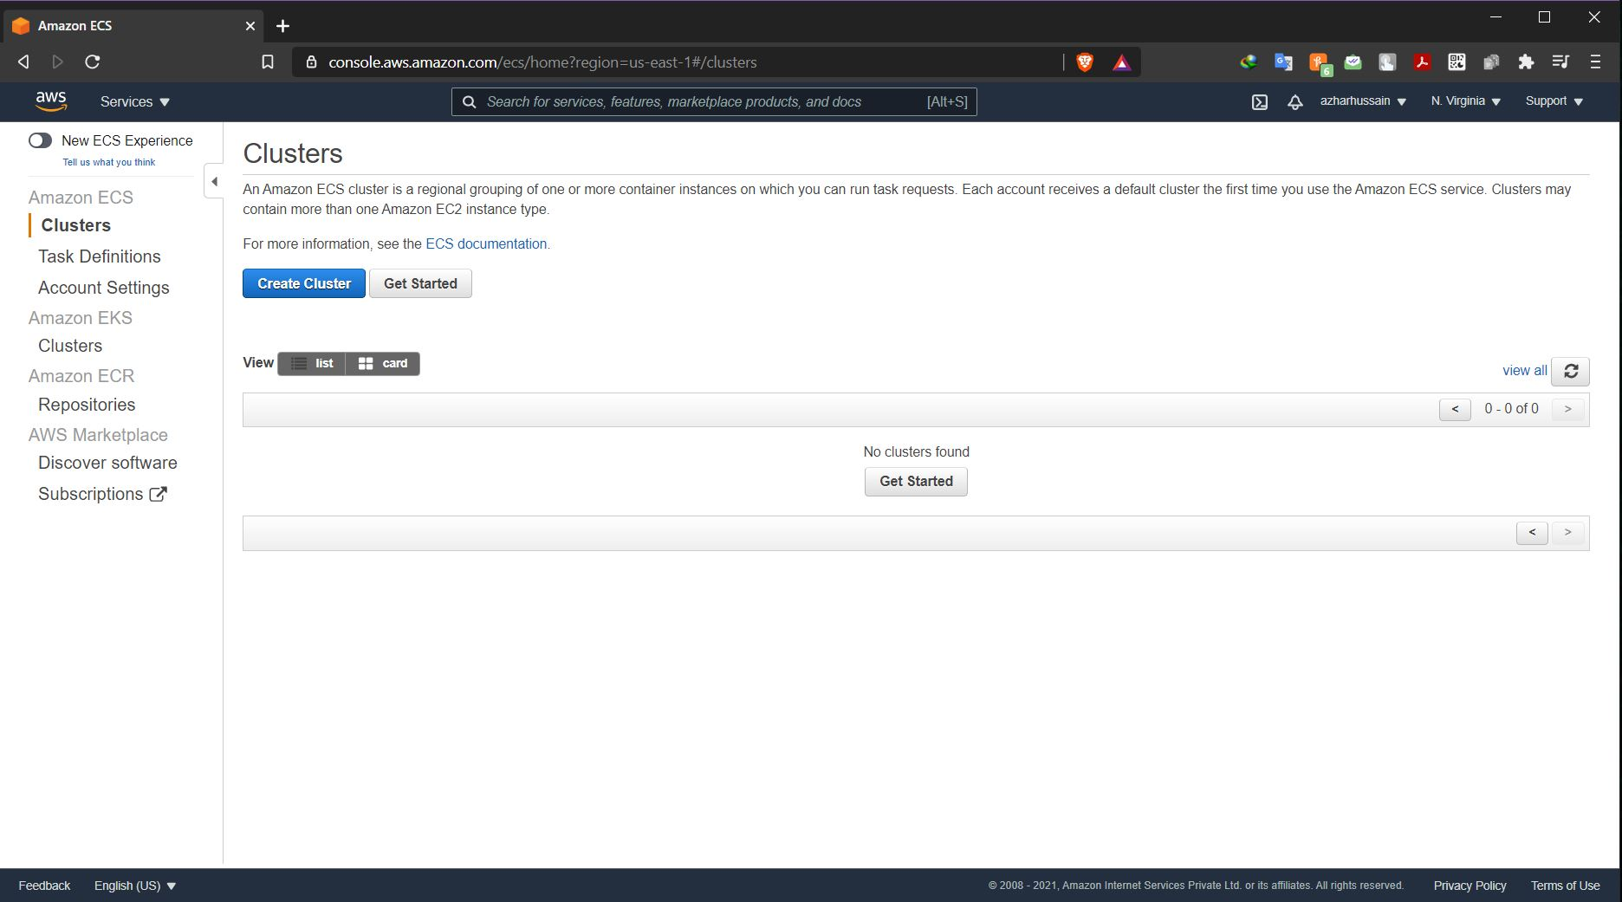

Step2: Creating container and task definition

ss: 2nd panel with all options visible

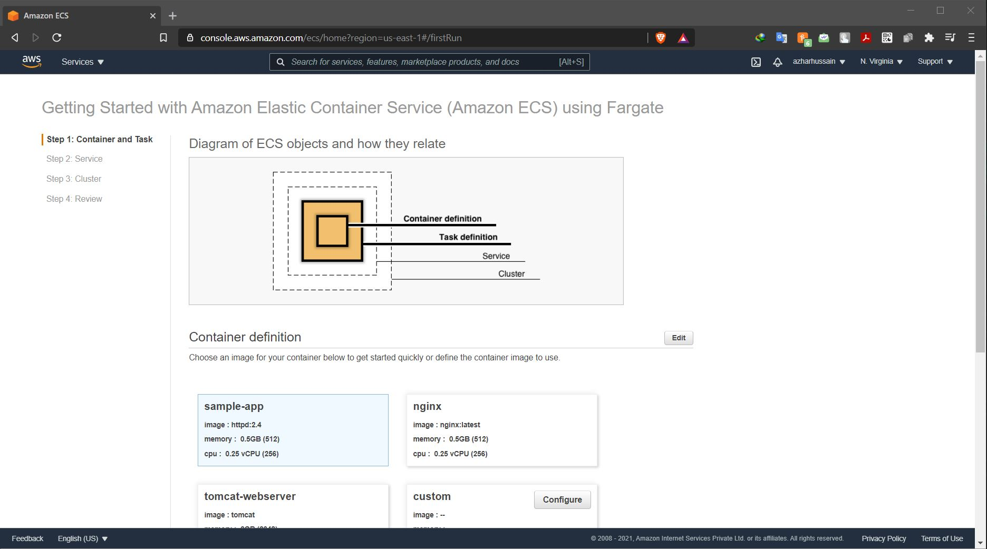

Step3: Configuring the service

ss: next panel

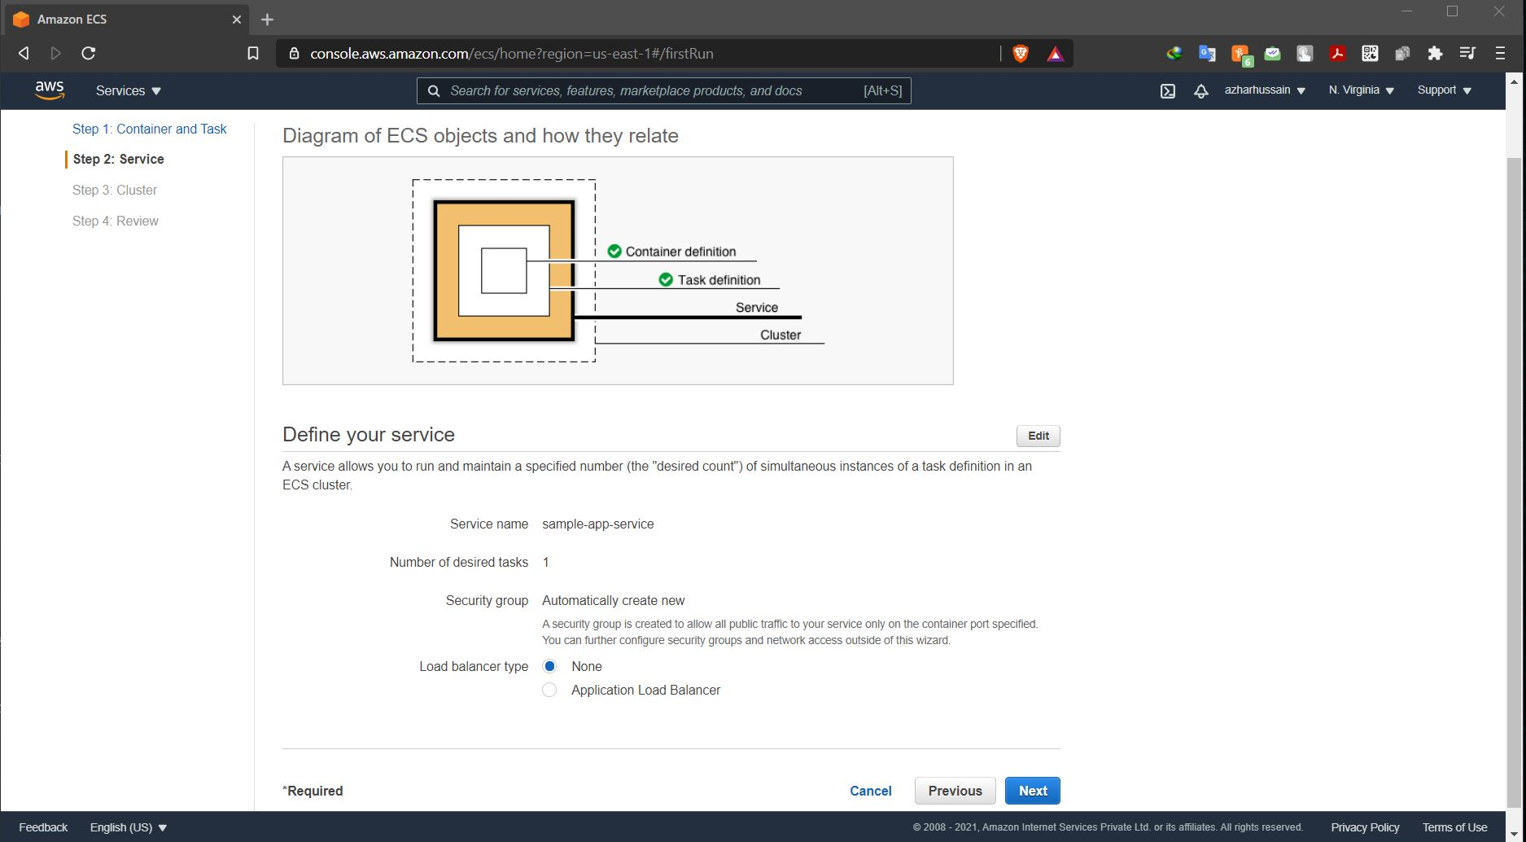

Step4: Configuring the cluster

ss: next panel

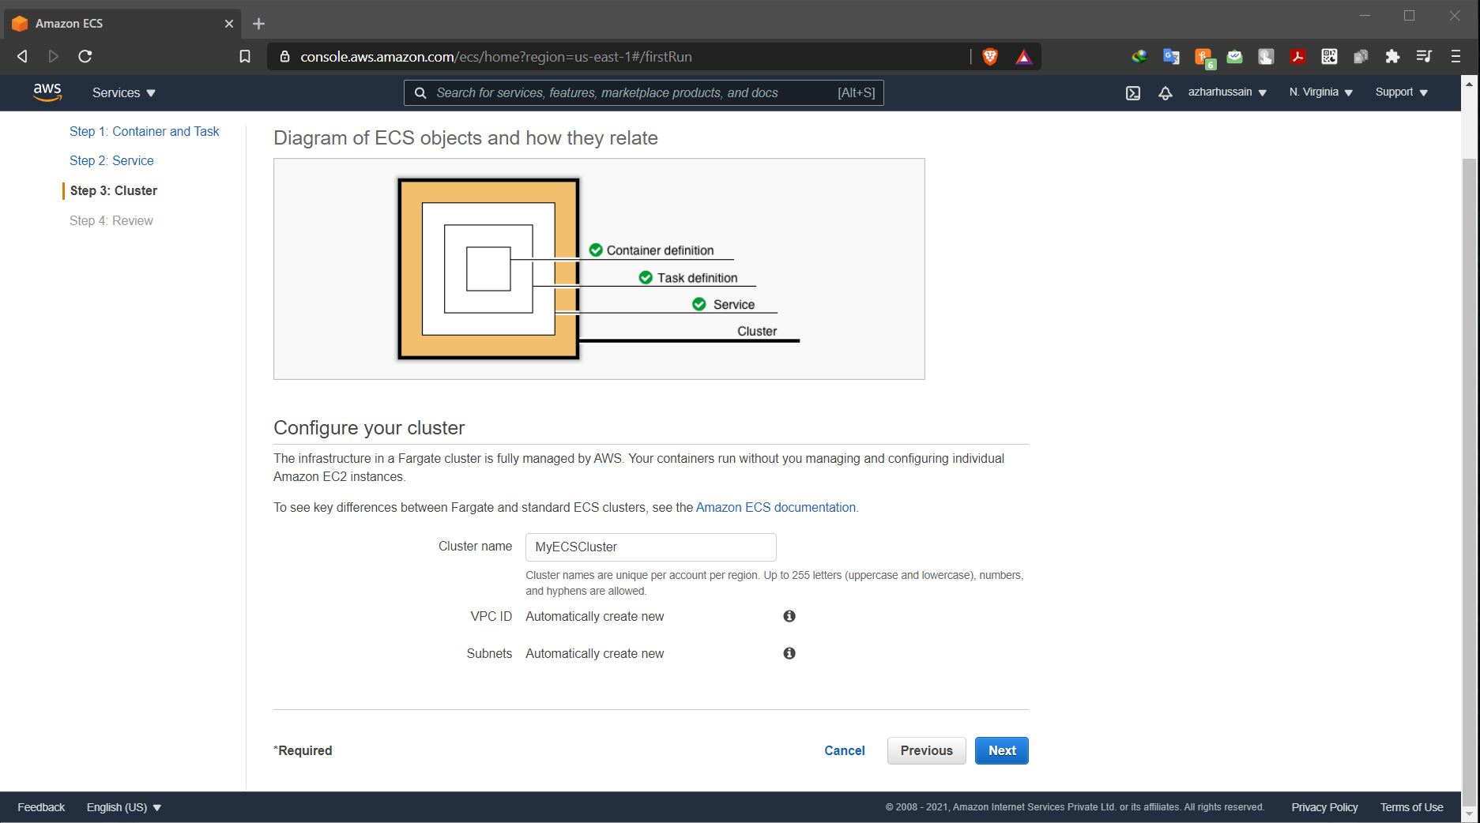

Step5: viewing the service

ss: Dashboard displaying the cluster created

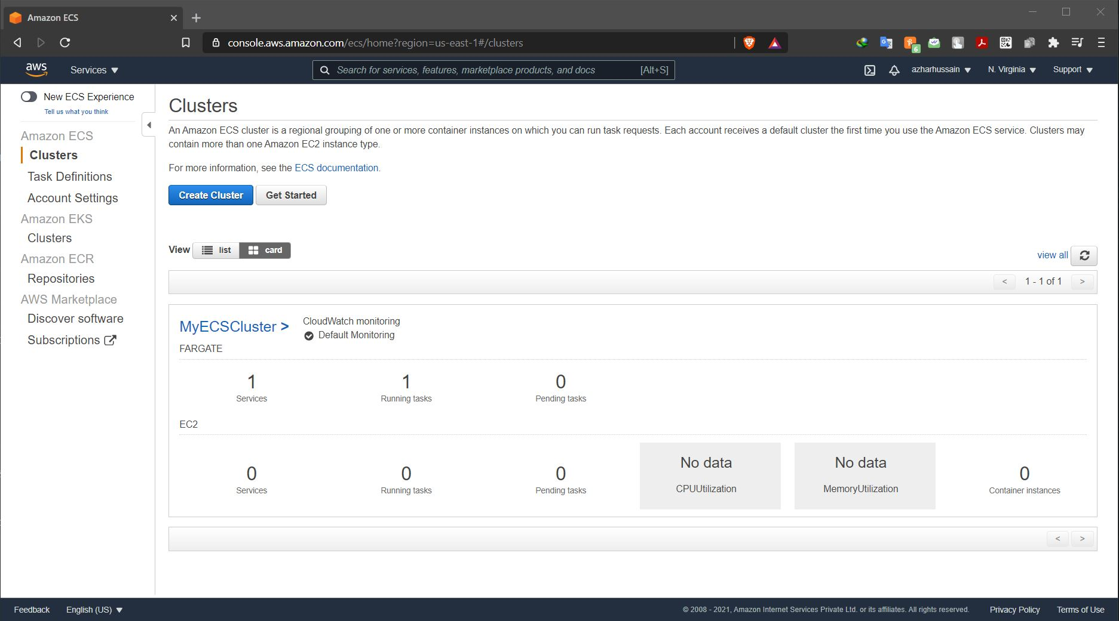

ss: cluster information

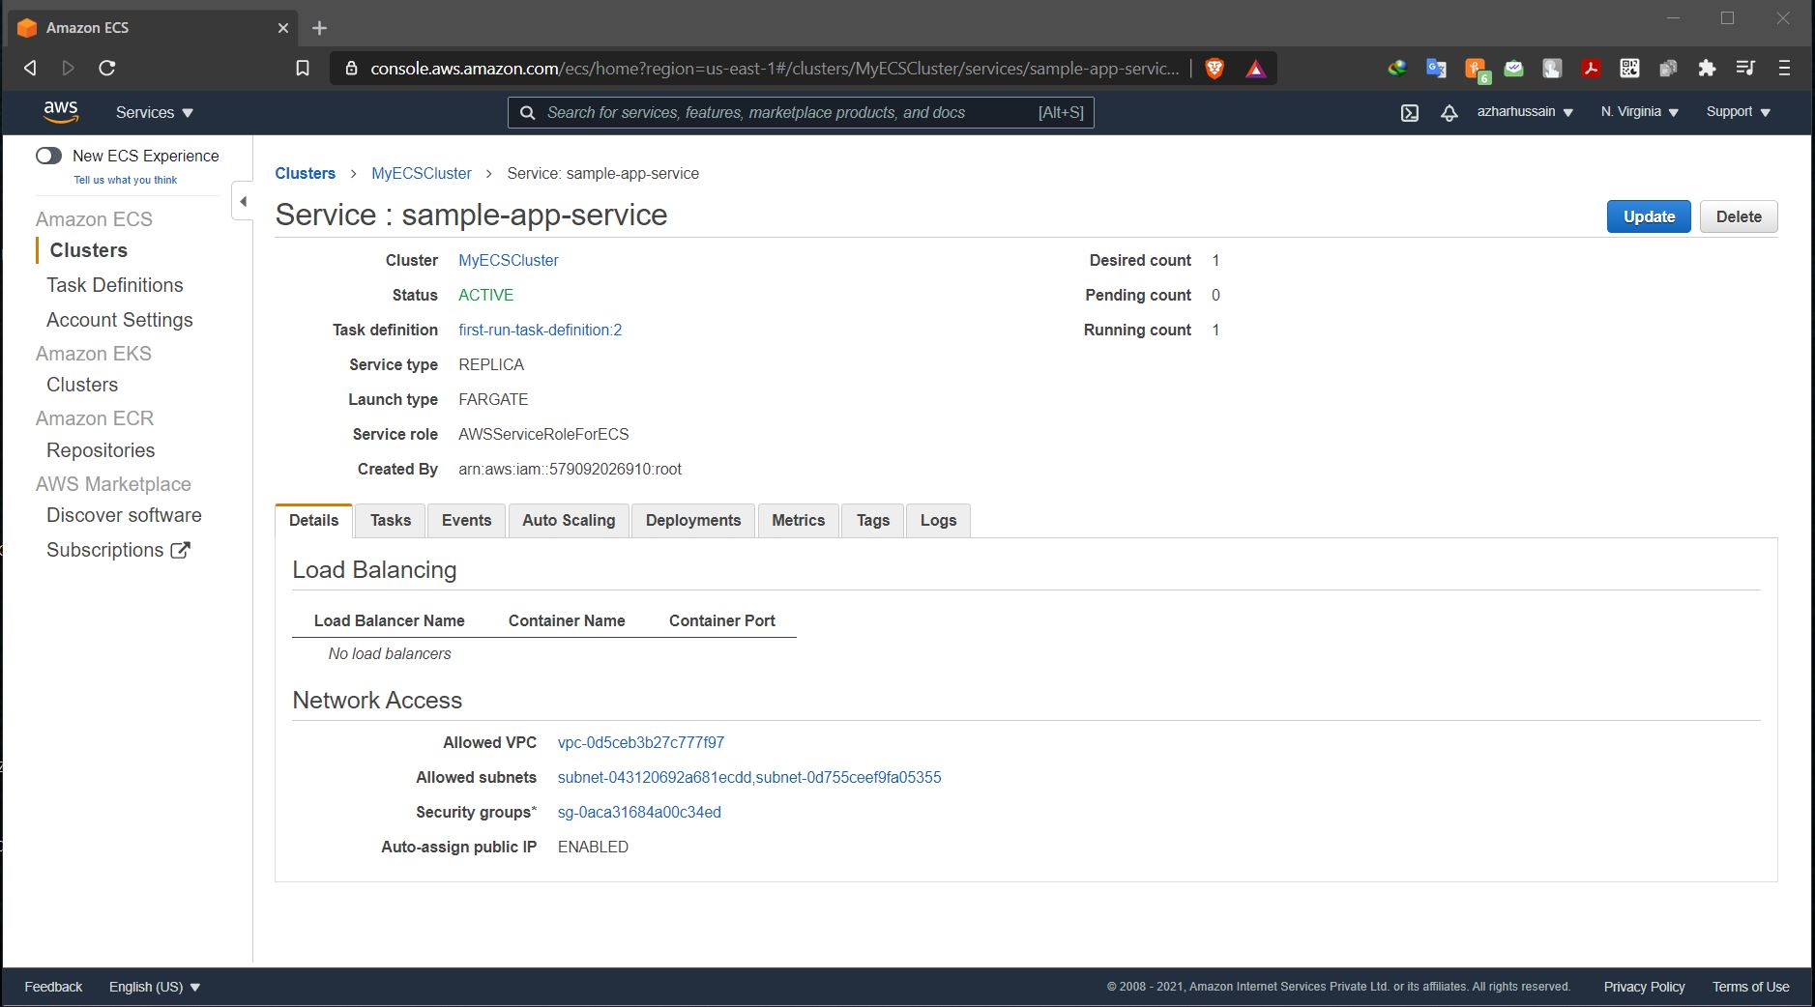

ss: panel displaying ENI ID

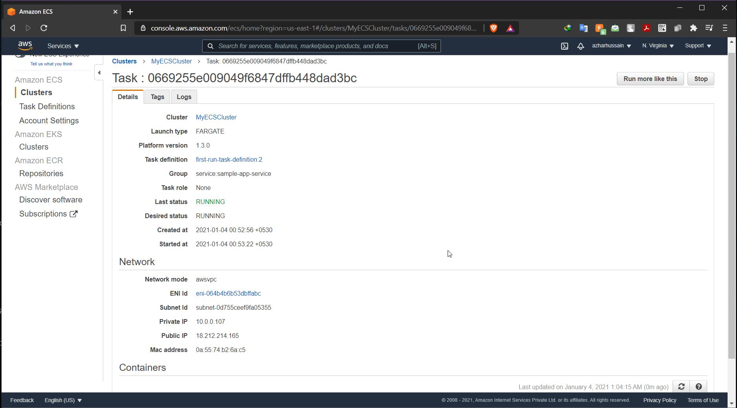

ss: Panel displaying the private, public, and the macid

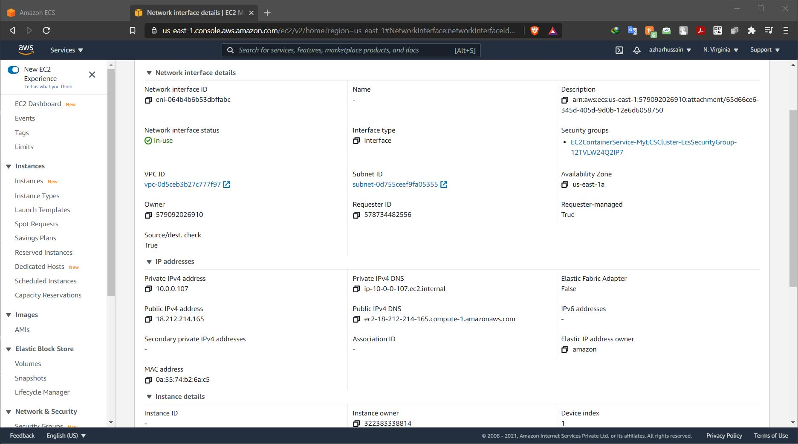

ss: display application

